

A Science Student’s Guide to Word 2016

By Christopher Mallon

A Science Student’s Guide to Word 2016

Christopher Mallon

English 380

University of Massachusetts Amherst

Acknowledgements

First, I’d like to acknowledge my friends and siblings who inspired this manual in the first place. It was their suggestions that set this project in motion, and their continued advice on a subject I had next to no experience to keep it rolling on to the end.

I’d like to thank all of my peers for their help throughout the manual’s development process; without their suggestions and criticisms this project would’ve been much poorer for it. I hope I was as much a help to all of your manuals as you were to mine.

And of course, I have to thank Prof. Solberg and [Stephanie Bergmann](https://www.linkedin.com/in/stephanie-bergmann/) for their informative and frank feedback. None of this would’ve been possible without them, and they deserve all of the credit (and none of the blame) for how everything turned out.

Cover Page image: uploaded by user geralt to Pixabay.com on June 13th, 2016 under Pixabay License https://pixabay.com/illustrations/mathematics-formula-physics-school-1453830/

Table of Contents

**Introduction**………………………………………………………………..………… 1

**Section I: Creating a New Document**…………………………………….. 2

1.1: Select Template…………………………………………..……………………… 2

1.2: Margins……………………………………………………………………………… 3

**Section II: Text Editing**…………………………………………………………… 4

2.1: Font Types…………………………………………………..…………………..… 4

2.2: Size & Effects……………………………………………………………………… 5

**Section III: Data & Graphics**………….…………………………………….... 6

3.1: Inserting Charts……………………………………………………………….…. 6

3.2: Insterting Pictures…………………………………………………………..….. 7

**Section IV: Finalizing Your Document**………………………………..…. 9

4.1: Adding Page Numbers……………………………………………………...…. 9

4.2: Front Matter………………………………………………………….…………. 10

4.2.1: Cover Page……………………………………………….………………………. 10

4.2.2: Table of Contents……………………………………………………………..… 12

4.3: Printing……….………………………………………………………….…………14

Introduction

Welcome to *A Science Student’s Guide to Word 2016*. This manual is designed to help college students use Microsoft Word 2016 for Windows to format their lab reports. whether you’re just starting out or a seasoned experimenter in your own right, don’t worry: this guide will show you the quickest and easiest ways to complete various formatting tasks that are specific to lab reports. Whether you just want a quick change of font or a complete overhaul of your report, this guide is here to help.

Lab reports are written to describe and analyze a laboratory experiment that explores a scientific concept. They are typically assigned to enable you to:

* Conduct scientific research
* Formulate a hypothesis about a particular event, process, natural law, etc.
* Organize the important details of your experiments so others can replicate them
* Apply statistics to test your hypothesis
* Evaluate research objectively and methodically
* Communicate concisely and precisely

Lab reports are central to the practice of science, and any scientist worth their salt should know how to clearly record and share their research. With this guide, you will gain the know-how necessary to submit your own research, and join in on the work to expand our understanding of the world we live in.

Section I: Creating a New Document

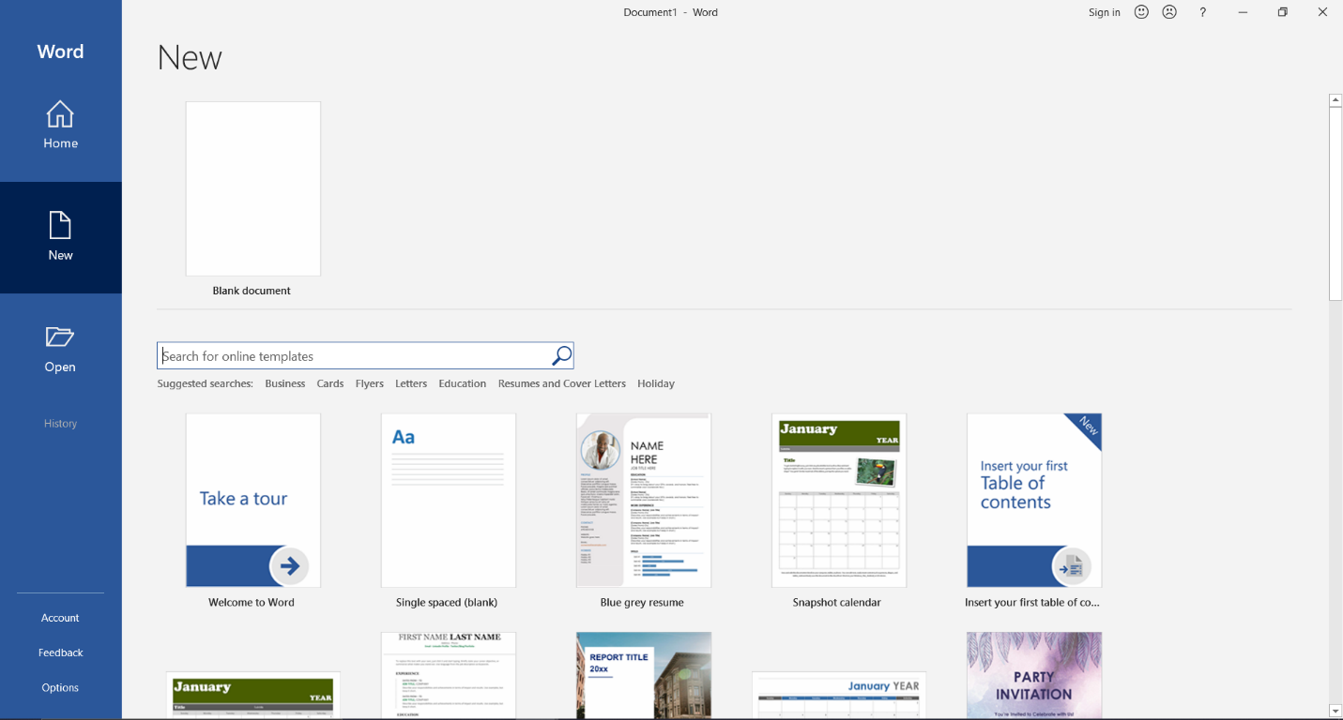

Search Bar

Figure

1.1: Select Template

It is helpful to start drafting a lab report by browsing the pre-generated templates that Word offers.

1. Open Microsoft Word 2016
2. Select the **New** button in the blue column on the left edge of the screen
3. Place your cursor in the search bar and type in any keywords associated with your project
4. Click through the options that appear and select one
5. Click **Create** to open a new document containing the template you selected

NOTE: Make sure to check out the formatting your professor wants **before** deciding on a template; a pretty format isn’t worth losing points!

1.2: Adjust Margins

Once you have generated your document, you can adjust the **Margins** of the page. The margins are the areas of white space which separate the text of a document from the edge of the page.

1. Select the **Layout** button in the bank of buttons at the top of the screen, called the **Toolbar**
2. Select the **Margins** button in the Layout subsection, or, **Ribbon**
3. In the Margins dropdown menu, there are several pre-generated margin options, such as Narrow (.5” all sides) or Wide (1” X 2”)
4. To create custom margins, select the **Custom Margins** button at the bottom of the menu
5. In the popup page, you can change the width of each margin individually

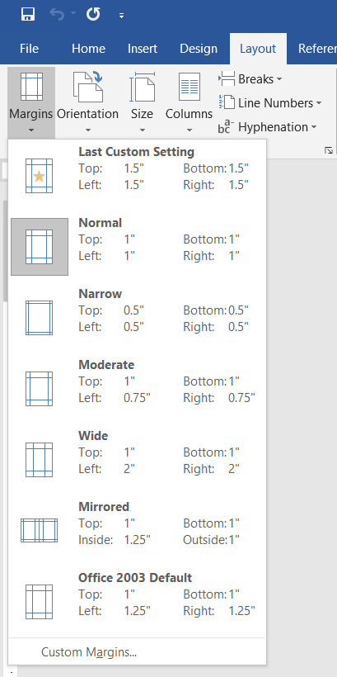

Figure

Section II: Text Editing

2.1: Font Types

**Font** is the style of your text. It is important to choose a font that is legible and professional.

1. Select the **Home** tab in the toolbar at the top of the screen to open the Home Ribbon
2. In the **Font** subsection of the Home ribbon, select the down arrow in the font menu (you can also use the shortcut *Ctrl + Shift + F* to quickly access the Font menu).
3. Select your preferred font*

NOTE: If you would like to change the font of a body of text that has already been written, hold the left mouse button and drag your cursor across the text. Once all necessary text has been highlighted, follow the above procedure and the selected text will change to the new font. If all text across a large space needs to be changed, you can use the shortcut *Ctrl + A* to select all text in a document.

*Your professor will almost certainly specify which font they would like your lab report to be written in – When in doubt, use Times New Roman or Calibri.

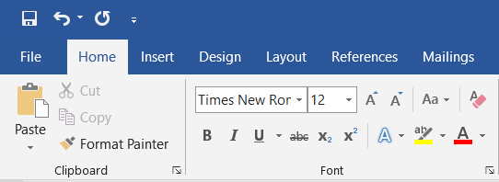

Font Size Menu

Font Menu

Superscript

Subscript

Italics

Underline

Bold

Figure

2.2: Font Size & Effects

Once you have selected a font style, you must choose the size of your text, as well as any special typographical qualities it must possess.

1. Select the text that you would like to change (see NOTE in Section 2.1).
2. To change the size of a text, select the down arrow next to the box with numbers in it.
3. Peruse the given size options (the highlighted text should change size to give you a preview of what it will look like when you hover over a given size) and select the one that best suits your needs*
4. To change the typography of a given text, use the bank of buttons located underneath the Font and Font Size menus:
   1. The bolded **B** icon bolds the highlighted text (*Ctrl + B*)
   2. The italicized *I* icon italicizes the highlighted text (*Ctrl + I*)
   3. The underlined U icon underlines the highlighted text (*Ctrl + U*)
   4. The X2 icon makes the highlighted text a subscript (*Ctrl + =*)
   5. The Xi icon makes the highlighted text a superscript (*Ctrl + +*)

*Again, your professor will almost certainly specify the font size they would like you to use. When in doubt, use size 12.

Section III: Data & Graphics

3.1: Insert Charts

Much like tables, **Charts** are very useful in representing your data, particularly when comparing two or more quantities or variables

1. Click the **Insert** tab
2. Under the **Illustrations** subsection, click the **Chart** button
3. In the dialogue box, select which type of chart you would like to use, then double click
4. Replace the default data with your own in the spreadsheet that opens
5. Close spreadsheet

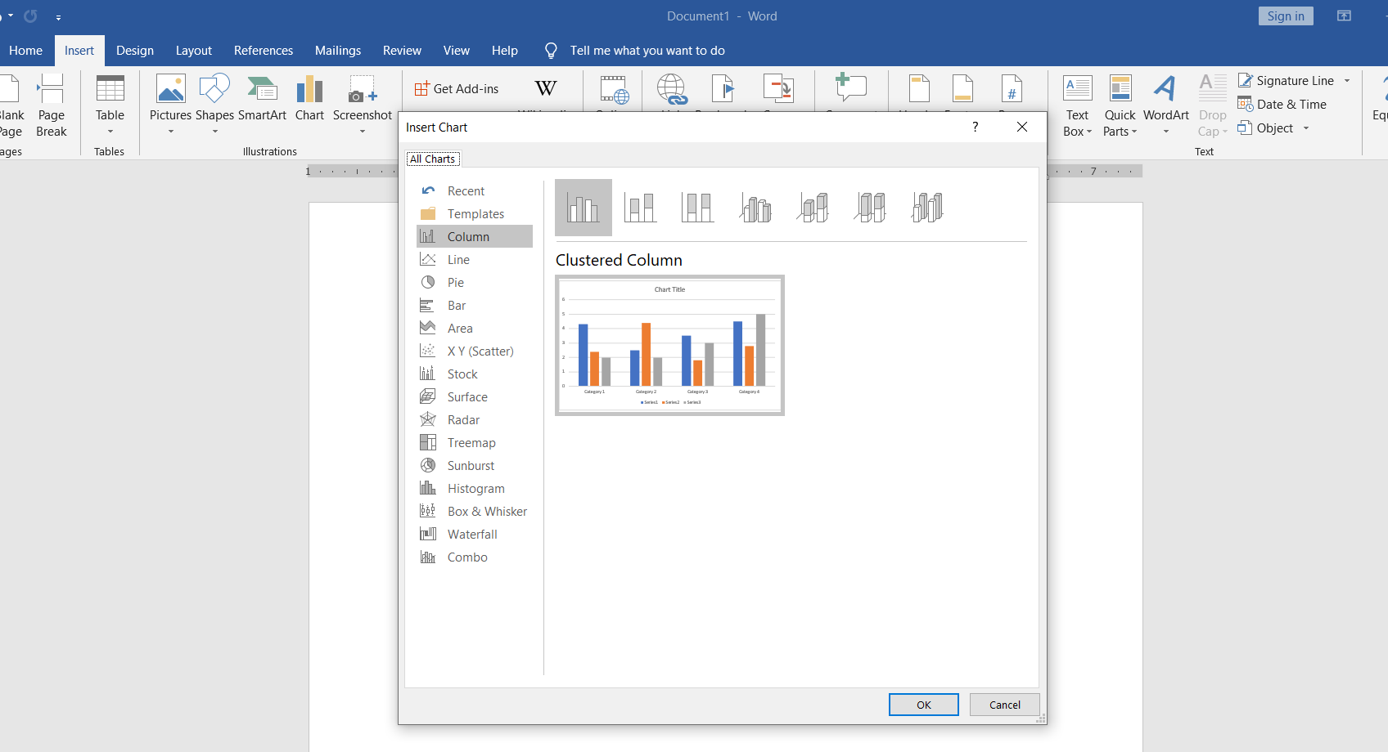

Chart options

Chart button

Figure

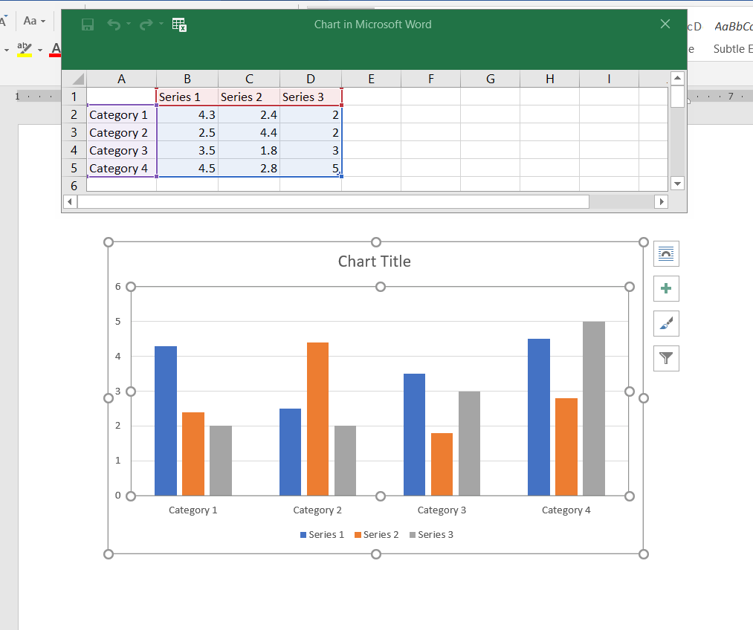

Chart Elements

Chart Styles

Edit your graph data here

Figure

You can further customize your chart by using the buttons located to the right of the chart

1. **Chart Elements** allows you to insert, hide, or format items such as axis titles or data labels
2. **Chart Styles** allows you to quickly change the look of your graph using Word’s pre-programmed styles

3.2: Insert Pictures

**Pictures** allow you to directly show your readers (and future experimenters) your work process and results. Such images may include microscope images, progress photos over a long-term experiment, or the outcome a chemical reaction.

1. Click the **Insert** tab
2. Click **Pictures** in the **Illustrations** subsection
3. Select **This Device** in the dropdown menu – this will open File Explorer
4. Select the image you need, and insert it

The image will appear where your cursor is, and can be moved around the document by moving the cursor, or click/dragging it.

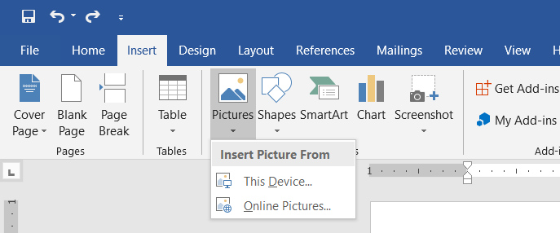

Select your image from File Explorer here

Figure

You can use text boxes to label each figure you use, as well as provide short description of what it shows

1. Select the graphic you would like to add a text box to
2. Click the **References** tab
3. In the **Captions** subsection, click the **Insert Caption** button – this will open a dialogue box
4. Type your caption under **Caption**
5. Select **Figure** under **Label**
6. choose whether the caption will be placed above or below the graphic
7. Click **OK**

Section IV: Finalizing Your Document

4.1: Add Page Numbers

Page numbers allow you to organize and cross-reference the pages of your lab report. Even if your lab report is a few pages long, page numbers greatly help readers (and future experimenters) effectively navigate your work.

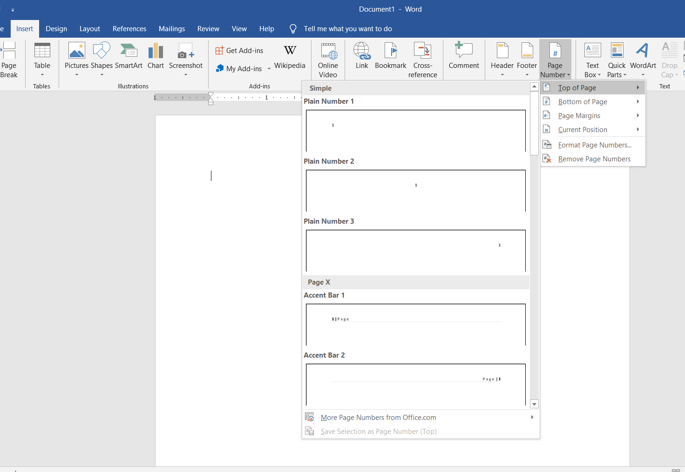

Figure

1. Click on the **Insert** tab
2. In the **Header & Footer** subsection, click **Page Number**
3. Select whether you would like the page numbers to appear on the top or bottom of the page in the dropdown menu
4. Select the placement of the page numbers:
   1. **Plain Number 1** orients the page number left
   2. **Plain Number 2** centers the page number
   3. **Plain Number 3** orients the page number right
5. Adjust the size and style of the page numbers as described in *Section II*
6. Double click anywhere in the body of your document to exit the Header & Footer Tools menu, or click the **Close Header & Footer** button

4.2: Front Matter

Your professor may require you to have a cover page and table of contents at the beginning of your document. The content which precedes the main body of a document is called the **Front Matter**.

4.2.1: Add Cover Page

1. Remove any page numbers from document
2. Click on the last page of your front matter, below all text on that page, to place your cursor there
3. Click on the **Layout** tab
4. Click **Breaks** in the **Page Setup** subsection and select **Next Page**, under **Section Breaks**

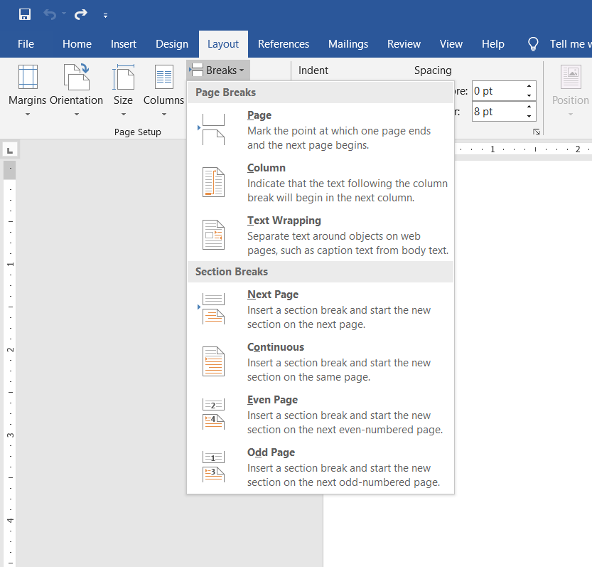

Figure

1. Double click on the header or footer to open the **Header & Footer Tools Menu**.
2. Click **Link to Previous** in the **Navigation** subsection of the **Header & Footer Tools** menu to deselect it
3. Click the **Page Number** icon in the **Header & Footer** subsection of the **Header & Footer Tools** menu and add a page number at the desired position.

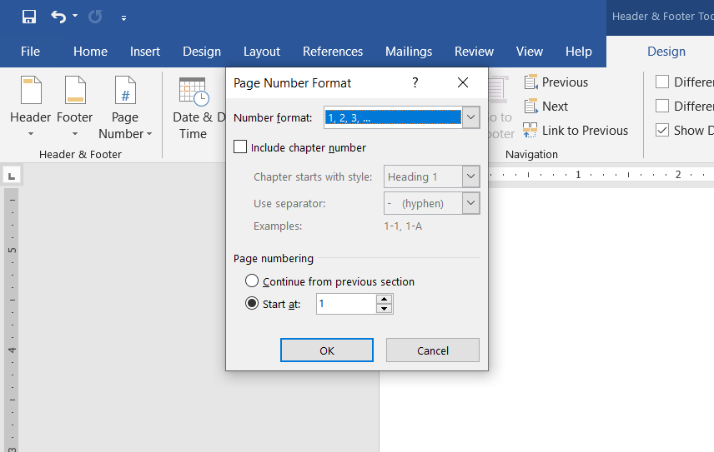

De-select **Link to Previous**

Page Number Icon

Figure

1. Click the **Page Number** icon again and select **Format Page Numbers**
2. Click the radio button next to **Start At** and type “1” into the box on the right.
3. Click OK at the bottom of the dialog box to apply your changes. Page numbering now begins at 1 on your first content page

4.2.2: Insert Table of Contents

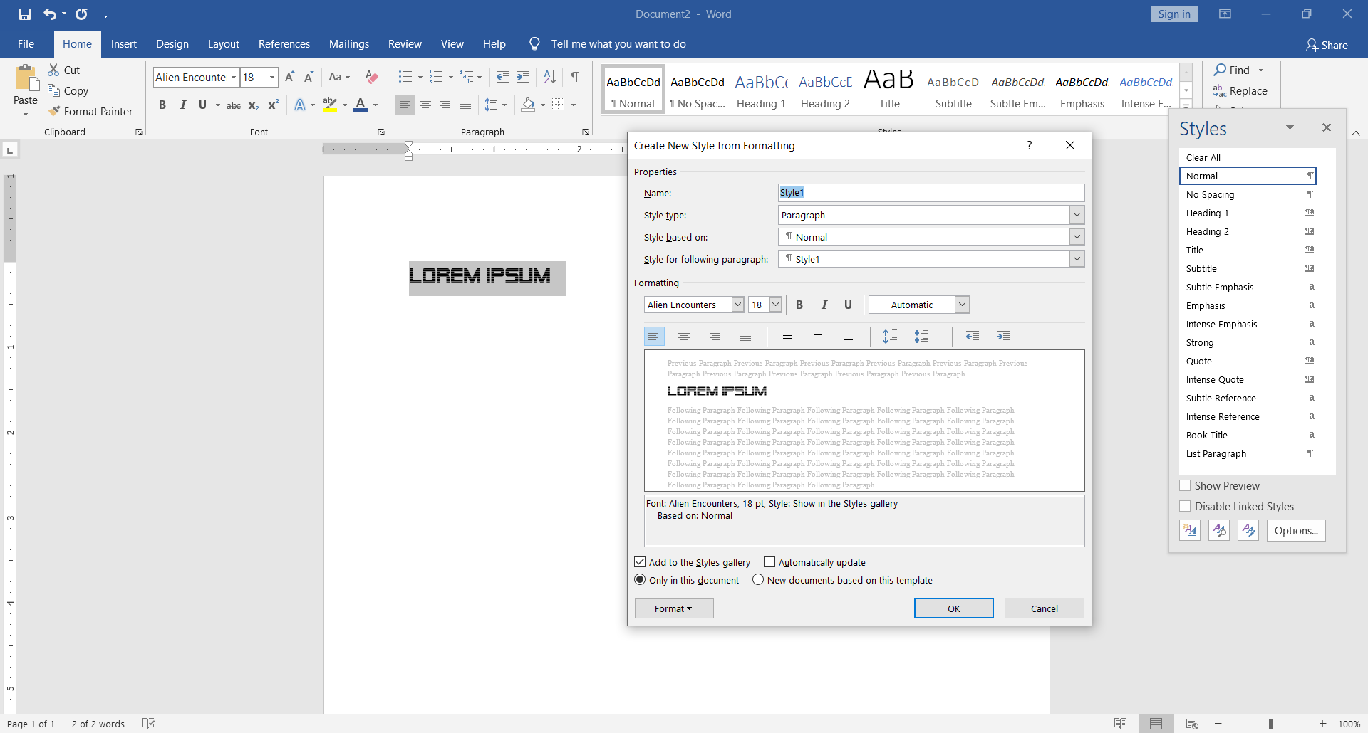

New Style icon

Name your style

Figure

Step 1:

1. Adjust the style of one of your section headings to your liking
2. Select the heading you have adjusted
3. Click the **Home** tab
4. Click the dialog box launcher on the right side of the **Styles** subsection to open the **Styles** menu
5. Click the **New Style** icon to open the **Creating New Style from Formatting** dialog box
6. Type a recognizable name for your heading style into the field next to **Name**
7. Click OK. Your new heading style appears in the list of styles in the Styles menu
8. Select another section heading in the lab report
9. Click on your new heading style in the **Styles** menu to apply that style to the selected heading
10. Repeat steps 8 and 9 for each section heading in the lad report

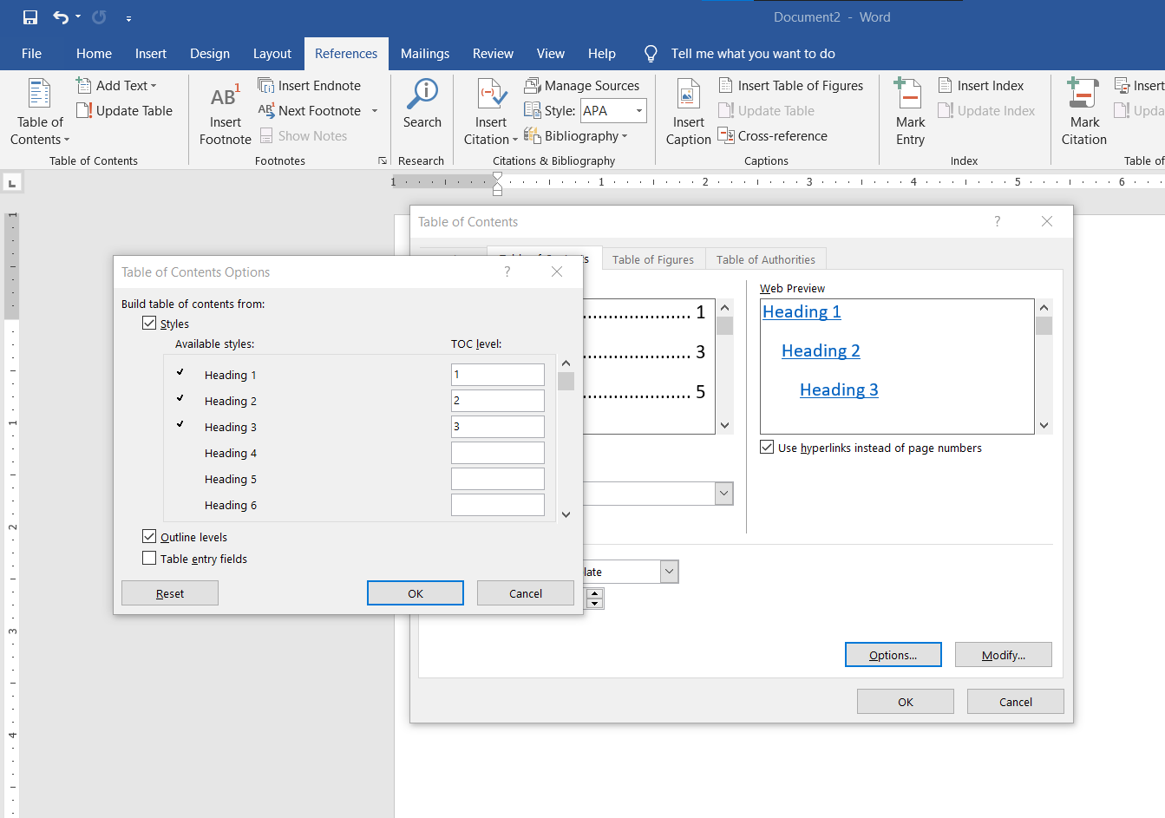

Type “1” next to your custom style

Table of Contents icon

Options

Figure

Step 2:

1. Click the **References** tab
2. Click the **Table of Contents** icon to open the **Table of Contents** dropdown menu.
3. Click **Custom Table of Contents**. The **Table of Contents** dialog box opens.
4. Click **Options**. The **Table of Contents Options** dialog box will open.
5. Delete all numbers in all fields under TOC level.
6. Scroll through the list of available styles until you find the heading style you used for your lab report.
7. Type “1” in the field that corresponds to your heading style under TOC level (Figure 17).
8. Click OK. The Table of Contents Options dialog box closes.
9. Click OK. The Table of Contents dialog box closes and a table of contents appears in your document.

4.3: Print

Once you have finished writing your lab report, you must print it for submission. Before completing these steps, go back through your lab report and carefully check for errors.

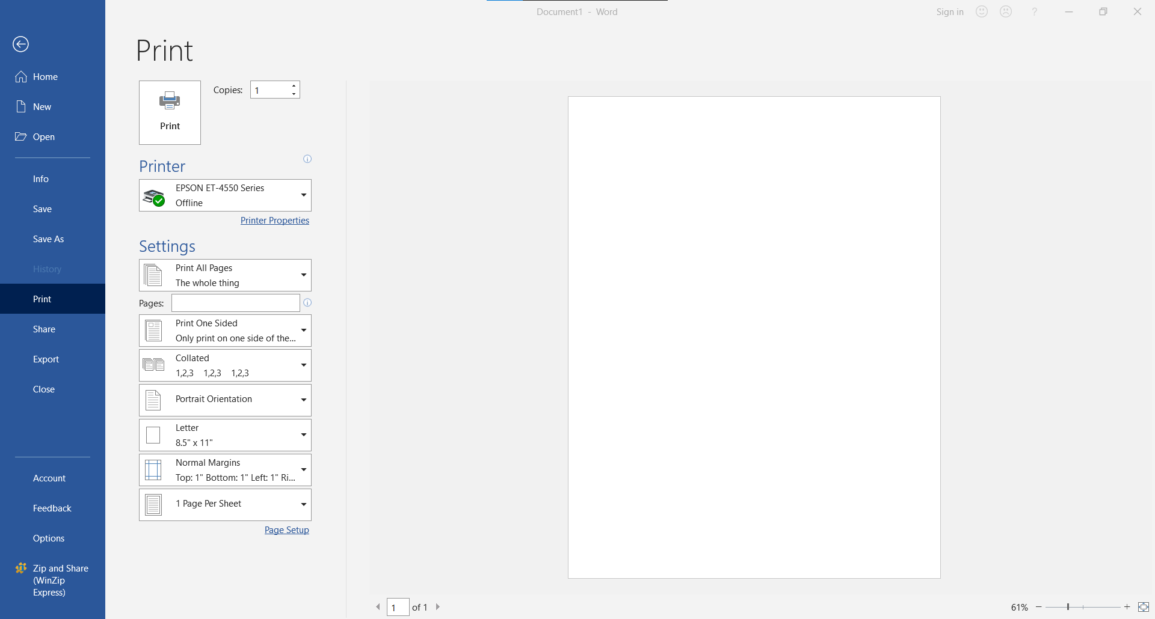

Formatting Options

Print Here

Choose Printer

Figure

1. Ensure that your computer is connected to a printer and the printer is on
2. Click the **File** tab to open the File menu
3. Click **Print** to open the Print menu
4. Click the dropdown menu under **Printer** and select the printer you want to print from
5. Click the first dropdown menu under **Pages** and select whether you want to print on one side or both sides of the page
6. Click Print